Providing Neonatal Care; why your baby may receive care in more than one hospital

The purpose of this leaflet is to explain why it may be necessary to move your baby from one hospital to another, to receive their care.

Maternity care is usually booked in the early stages of pregnancy at your local hospital. These hospitals can provide immediate care for babies who are born unexpectedly premature or sick. However, not all hospitals have the facilities needed to provide on-going care for the sickest and smallest babies.

Neonatal Units are different, depending on the type of care they provide;
Neonatal Intensive Care Units (NICUs) look after preterm infants from 22 weeks' gestation, sick term infants, and babies who need complex specialist care such as babies needing surgery or who have a heart problem.
Special Care Baby Units (SCBUs) look after babies from 30 weeks gestation, who do not require intensive care.
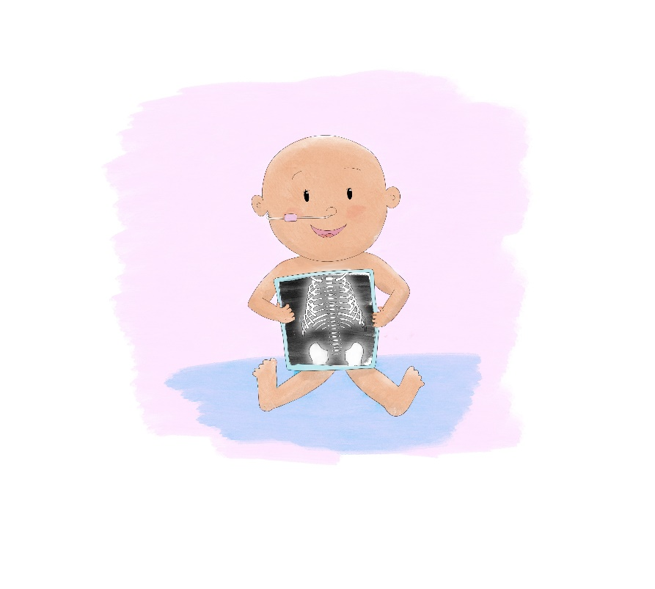

Within the Northern Neonatal Network, there are ten different neonatal units.

We have three NICUs and seven SCBUs.

All the units have specially qualified neonatal staff, who can care for your baby at each stage of their neonatal journey.

Deciding where your baby should receive their care

If your baby is likely to be born below 30 weeks, they will need to be cared for in a hospital that can provide intensive care. This may not be the hospital closest to your home. To ensure that your baby receives the right level of care, you may be moved to a different hospital before they are born. Other babies who are unexpectedly sick or premature may require a transfer to an intensive care unit after they are born.

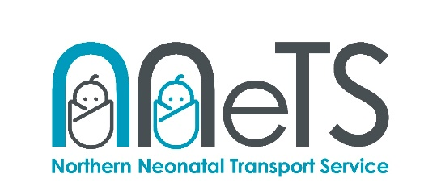
We have a specialist neonatal transfer service (NNeTS), with dedicated doctors and nurses who are very experienced in caring for sick or preterm infants. This is the team who transfer babies between hospitals in our region.
You will be given the option to travel alongside your baby, if it safe to do so.

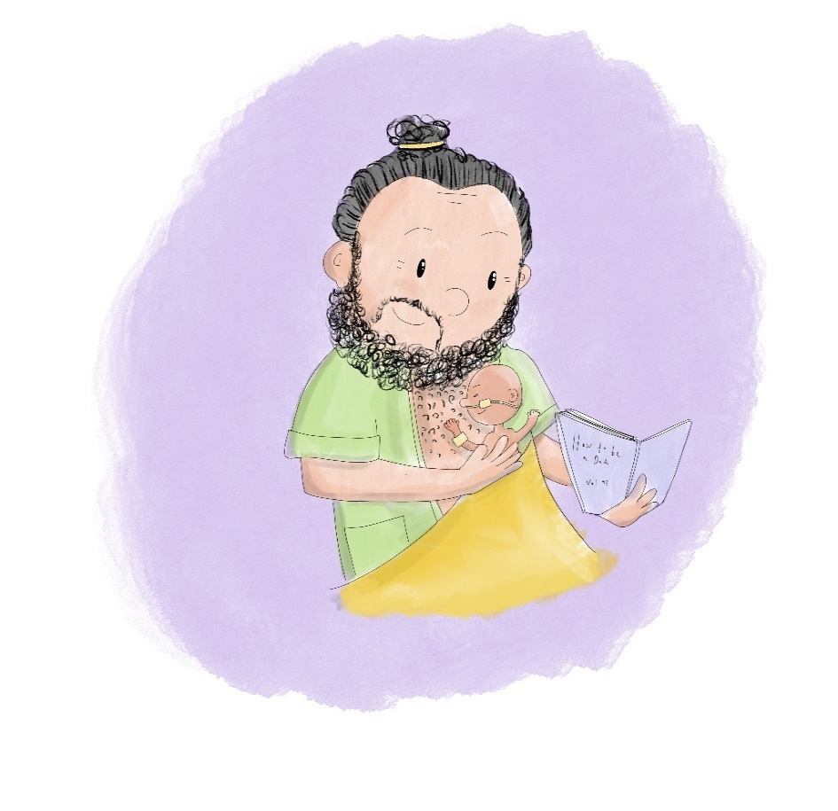

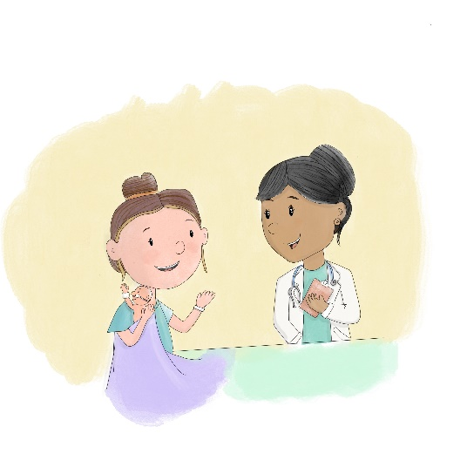
Care closest to home

As your baby’s care needs change, we always aim to move them back to your local unit as soon as they are well enough, and it is safe to do so. This will be planned between the teams caring for your baby and yourselves. Moving from one unit to another can be stressful for families, but we will make every effort to support you throughout your baby’s transfer.

The unit your baby is moved to may be different from the unit you booked in for maternity care. Neonatal care is provided on a needs basis, as close to home as possible. Follow up services are also dependent on your home address; this is one of the reasons why transferring back to your local unit is important at this stage.

Preparing to transfer

You may have met the team in your local unit before your baby was transferred for specialist care. If you haven’t then this can be arranged for you. Your local unit will receive regular updates on your baby’s progress and will be aware of your family’s needs. This should help with the transition between one unit and another.
We would never transfer your baby without discussion with yourselves, however the unit may need to contact you at short notice if the neonatal unit becomes full, and your baby’s care needs can be safely met by a local unit closer to home.
It may take several days to settle in and feel more comfortable in a new unit. This is very normal, but your new setting will soon become more familiar. Your local unit will be ready to help you to continue to develop your relationship with your baby, and to help them flourish and grow, with the additional support of those closest to you, who know you and you baby best.

You can find more information about the units in our network by scanning below:

Many thanks to the parents from the Northern Neonatal Network’s Parent Advisory Group & Maternity & Neonatal Voices Partnership who helped with this leaflet.

